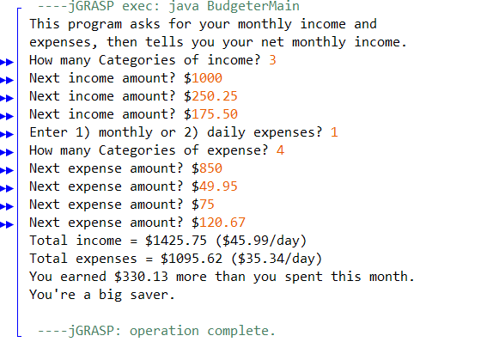
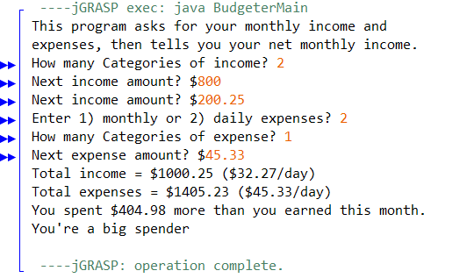
BudgeterMain
BudgeterHelper
OpeningMessage
GetTotalIncome
GetTotalExpense
FinalBudgeter
PrintSavings

- BudgeterMain
  - BudgeterHelper is where all the code will go
- OpeningMessage
  - Display an opening message that tells the user what the program will do
- GetTotalIncome
  - Create an int for choices and categories and a double for sum
  - Ask if it’s monthly or daily expenses and how many categories
  - Ask for the next expense amount
- PrintSavings
  - Adds up the total income and expenses the user inputed
  - Says how much more you earned than you spent this month
  - Says “You’re a big saver” or “You’re a big spender” depending on how much was saved or spent
- FinalBudgeter
  - Puts the previous methods into a single method that can be called by the main file

